VAPS

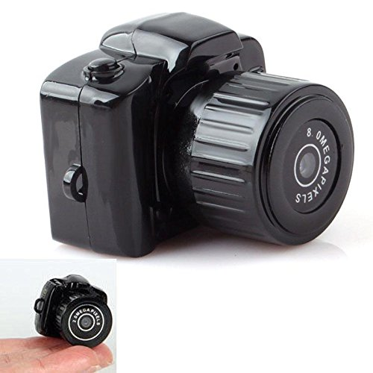

Specification:

Cost :20.19$ amazon

Video compression: MPEG4.  
Video format: AVI.  
Video resolution: 1280 X 720@30fps.  
Picture mode: JPG.  
Picture resolution: 3264 X 2448.  
Storage media: Micro SD card support SDHC.  
Support capacity: Max 32GB.  
Interface port: USB 2.0.  
System: Window me/2000/xp/2003/7/vista;Mac os 10.4;Linux.  
Recharge Voltage: DC-5V.  
Battery: lithium polymer battery.  
Size: 3.5cm x 3cm x 3cm - 1.38inch x 1.18inch x 1.18inch.

Interface:

External memory card(card not included).  
Built-in microphone.  
Built-in lithium battery.  
One-touch recording button.  
Support Circulating video, 3minutes for each fragment.

Cam2:

Cost :75$ spyville

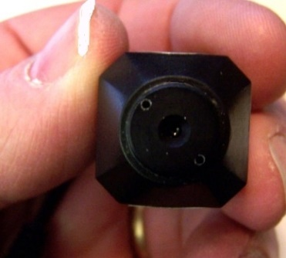

**Specifications**

* Reference : http://www.spyville.com/wireless.html
* 8V DC (camera)
* 380-Line Resolution Ratio (camera)
* 1.5 Lux Illumination (camera)
* 2.4 GHz frequency (4 Channel) (receiver)
* 12V AC adapter (receiver)
* 7/8″ x 7/8″ x 1″
* 2.225*2.225*2.54 cm

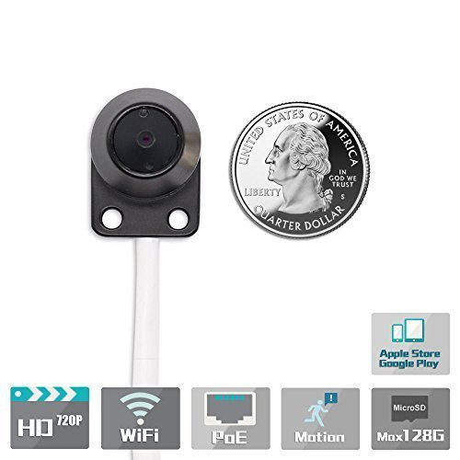

CAM3:

Reference:amazon

Company:TitaThink

Cost :188$

Dimensions: 3.7 x 2.87 x 0.94 in (WxDxH)

Works wirelessly with wifi

720p

1. Works over Wi-Fi b/g/n, LAN or POE. WPS for easy wireless setup.   
   2. One Audio Line-in port, Connect an external sound pick-up for sound monitoring.   
   3. General I/O which is used to connect external alarm devices.   
   4. Multi-zone Motion Detection, Email, Ftp, Push alarms to your phone.   
   5. Support local MicroSD memory card recording, Max up to 128G. Play back via our app or software.   
   6. ONVIF and Nas Compliant, paired with NVR, NAS or other security system.   
   7. Free app for iphone, ipad, Android Smartphones and Tablets.

CAM4:

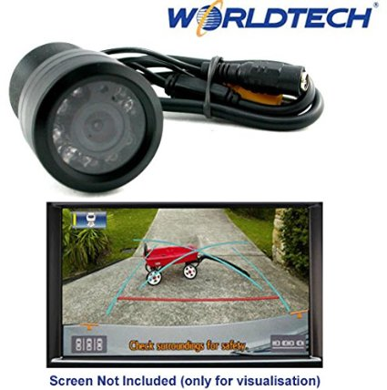

CAM5:

NIGHTVISION ALSO

Rs.5000

VISUAL ANGLE 120 DEGREE

